
ST ANDREW’S JUNIOR COLLEGE
Preliminary Examinations
Higher 1

H1 Geography 8834/01
Paper 1 28 August 2025
INSERT 3 hours

READ THESE INSTRUCTIONS FIRST

This insert contains all the Resources referred to in the questions.

This document consists of 10 printed pages
[Turn over

Resource 1 for Question 1

Map of the fieldwork locations

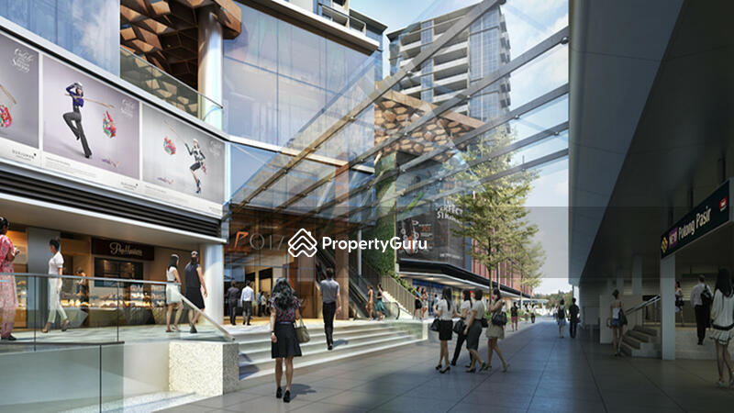
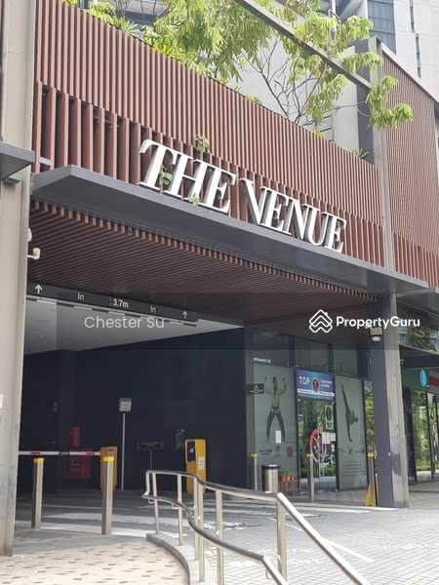

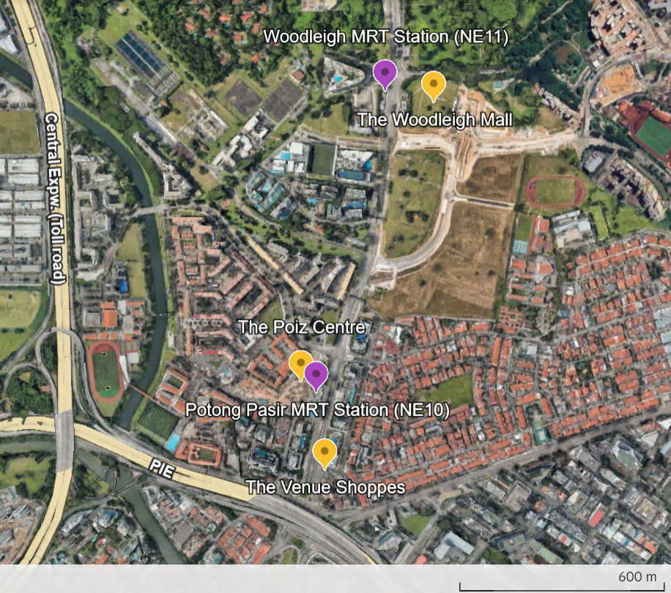

Resource 2 for Question 1

Questionnaire survey used at the three malls

Age: ☐ 60–64 ☐ 65–69 ☐ 70–74 ☐ 75–79 ☐ 80+ ☐ Prefer not to say
Gender: ☐ Male ☐ Female ☐ Prefer not to say
Ethnic group: ☐ Chinese ☐ Malay ☐ Indian ☐ Others ☐ Prefer not to say

Q1. Have you heard of the Silver Volunteer Fund?
☐ Yes
☐ No
Q2. Do you think programmes like SVF make seniors happier?
☐ Yes
☐ No
☐ Not sure
Q3. In the past year, have you volunteered in any community activity?
☐ Yes
☐ No
Q4. Which of these benefits do you think seniors get from volunteering?
(Select all that apply)
☐ Meeting new friends
☐ Better physical health
☐ Better mental health
☐ Extra income
☐ None of the above

Q5 continues on the next page.
[Turn over
[Turn over

Q5. “Seniors who volunteer live longer than those who do not.” Do you agree or disagree?
☐ Strongly agree
☐ Agree
☐ Disagree
☐ Strongly disagree

Resource 3 for Question 1
Selected results of the questionnaire survey

Question | Response Options | Poiz Centre (n=10) | Venue Shoppes (n=10) | Woodleigh  Mall (n=10) | Total
Q1. Heard of SVF? | Yes | 3 | 2 | 4 | 9
Q1. Heard of SVF? | No | 7 | 8 | 6 | 21
Q2. Think SVF makes seniors happier? | Yes | 5 | 6 | 7 | 18
Q2. Think SVF makes seniors happier? | No | 3 | 2 | 2 | 7
Q2. Think SVF makes seniors happier? | Not sure | 2 | 2 | 1 | 5
Q3. Volunteered in past year? | Yes | 4 | 3 | 5 | 12
Q3. Volunteered in past year? | No | 6 | 7 | 5 | 18
Q4. Benefits from volunteering (multiple choice) | Meeting new friends | 4 | 5 | 6 | 15
Q4. Benefits from volunteering (multiple choice) | Better physical health | 3 | 4 | 4 | 11
Q4. Benefits from volunteering (multiple choice) | Better mental health | 5 | 6 | 7 | 18
Q4. Benefits from volunteering (multiple choice) | Extra income | 1 | 0 | 2 | 3
Q4. Benefits from volunteering (multiple choice) | None of the above | 2 | 3 | 1 | 6
Q5. Agree: “Seniors who volunteer live longer” | Strongly agree | 1 | 2 | 3 | 6
Q5. Agree: “Seniors who volunteer live longer” | Agree | 5 | 4 | 5 | 14
Q5. Agree: “Seniors who volunteer live longer” | Disagree | 3 | 3 | 2 | 8
Q5. Agree: “Seniors who volunteer live longer” | Strongly disagree | 1 | 1 | 0 | 2

[Turn over
Resource 4 for Question 1

Demographic profile of respondents compared to Singapore’s population distribution in 2024

Category | Respondent Profile | Singapore Resident Population Distribution (2024)
Age | 60–64: 9 (30%)  65–69: 7 (23%)  70–74: 6 (20%)  75–79: 4 (13%)  80+: 2 (7%)  Prefer not to say: 2 (7%) | <20 yrs: 18.8%  20–64 yrs: 63.1%  65+ yrs: 18.0%
Gender | Male: 12 (40%)  Female: 16 (53%)  Prefer not to say: 2 (7%) | Male: ~48.7%  Female: ~51.3%
Ethnicity | Chinese: 21 (70%)  Malay: 4 (13%)  Indian: 3 (10%)  Others: 1 (3%)  Prefer not to say: 1 (3%) | Chinese: 74.0%  Malay: 13.5%  Indian: 9.0%  Others: 3.4%

Resource 5 for Question 2

Huinnyeol Cultural Village in the 1950s

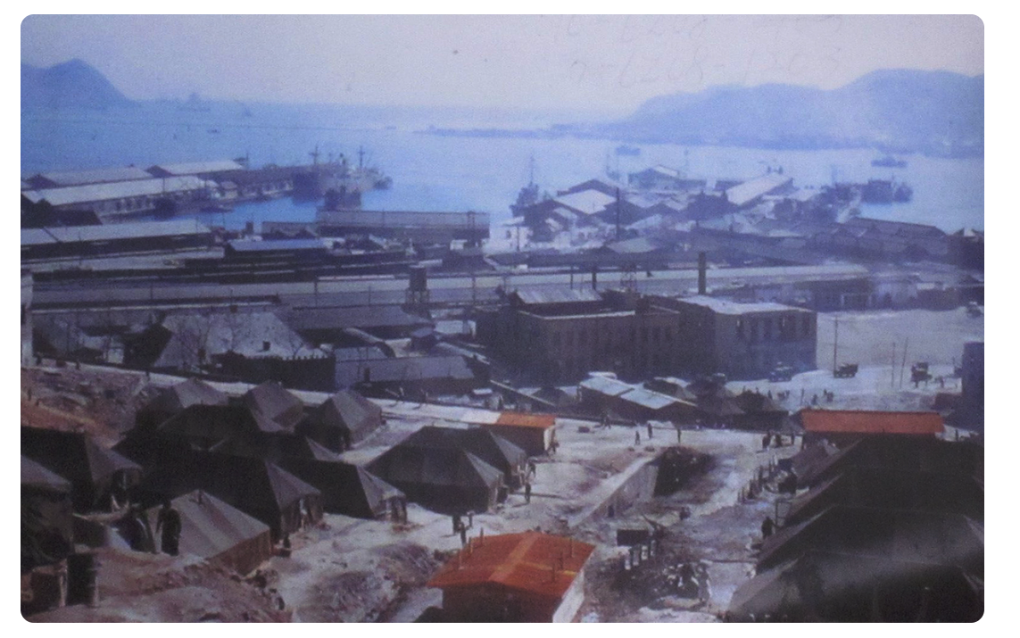

[Turn over
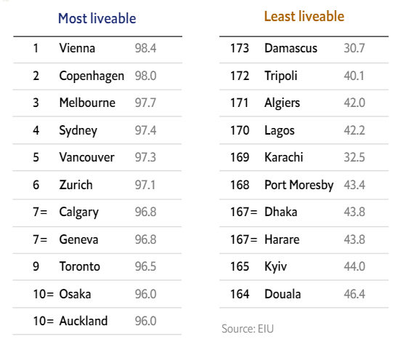
Resource 6 for Question 2

Huinnyeol Cultural Village today

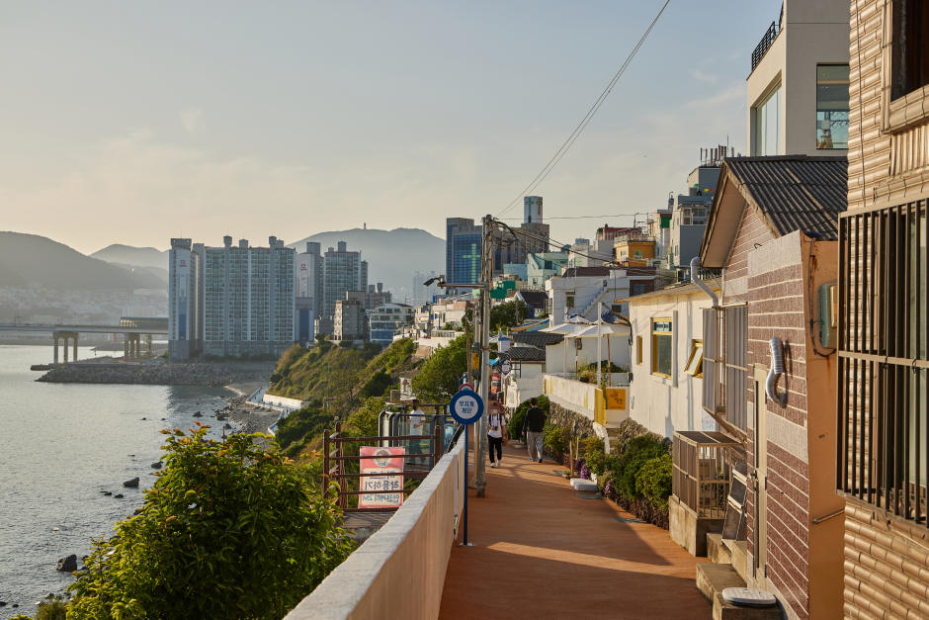

Resource 7 for Question 2

Population of selected districts in Busan in 5-year intervals from 2005 to 2020

District | 2005 | 2010 | 2015 | 2020
Busanjin-gu | 399162 | 380395 | 376321 | 351403
Dong-gu | 103658 | 93976 | 89202 | 87246
Gangseo-gu | 46638 | 54347 | 92628 | 136734
Haeundae-gu | 393718 | 410084 | 409037 | 389535
Jung-gu | 52446 | 48197 | 45377 | 41439
Seo-gu | 133014 | 116600 | 111996 | 105303
Yeongdo-gu | 158117 | 139723 | 129515 | 113224

Resource 8 for Question 3

Cumulative change in mass of ice sheets, measured relative to a base year of 2002 (t = tons)

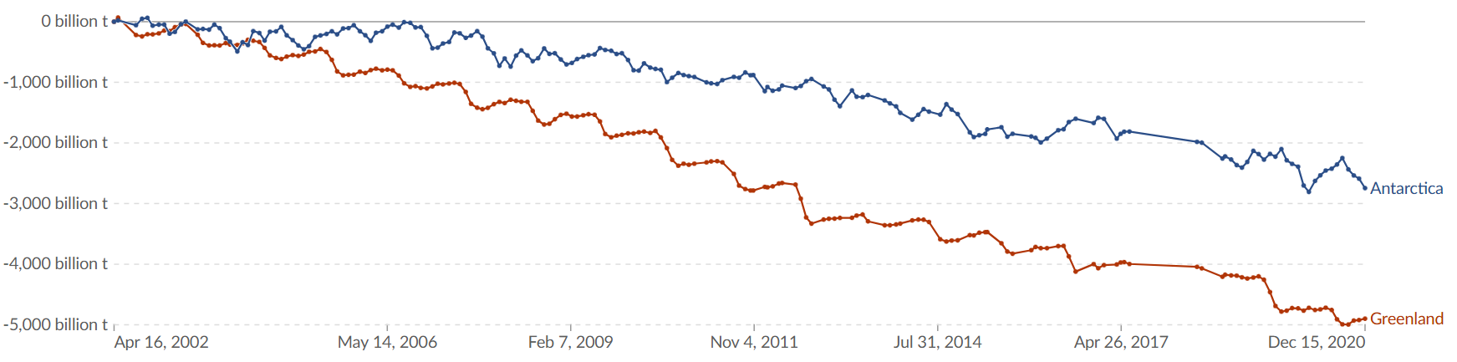

For reference, 1,000 billion metric tons is equal to about 260 cubic miles of ice, enough to raise sea level by about 3 millimeters.

[Turn over

Resource 9 for Question 3

Asian cities to experience climates extremes

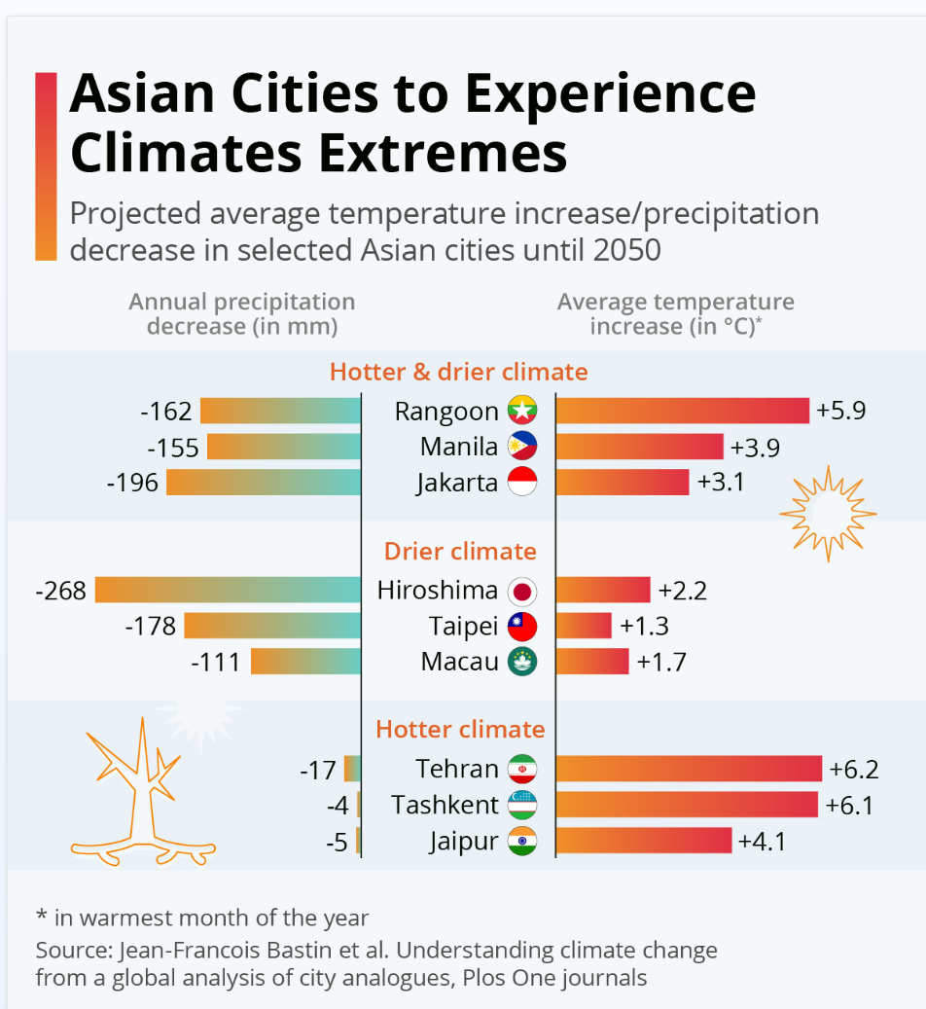

Resource 10 for Question 3

Impacts of atmospheric carbon dioxide concentration

